**Managing Processes Lab**

## Accessing the AWS Management Console

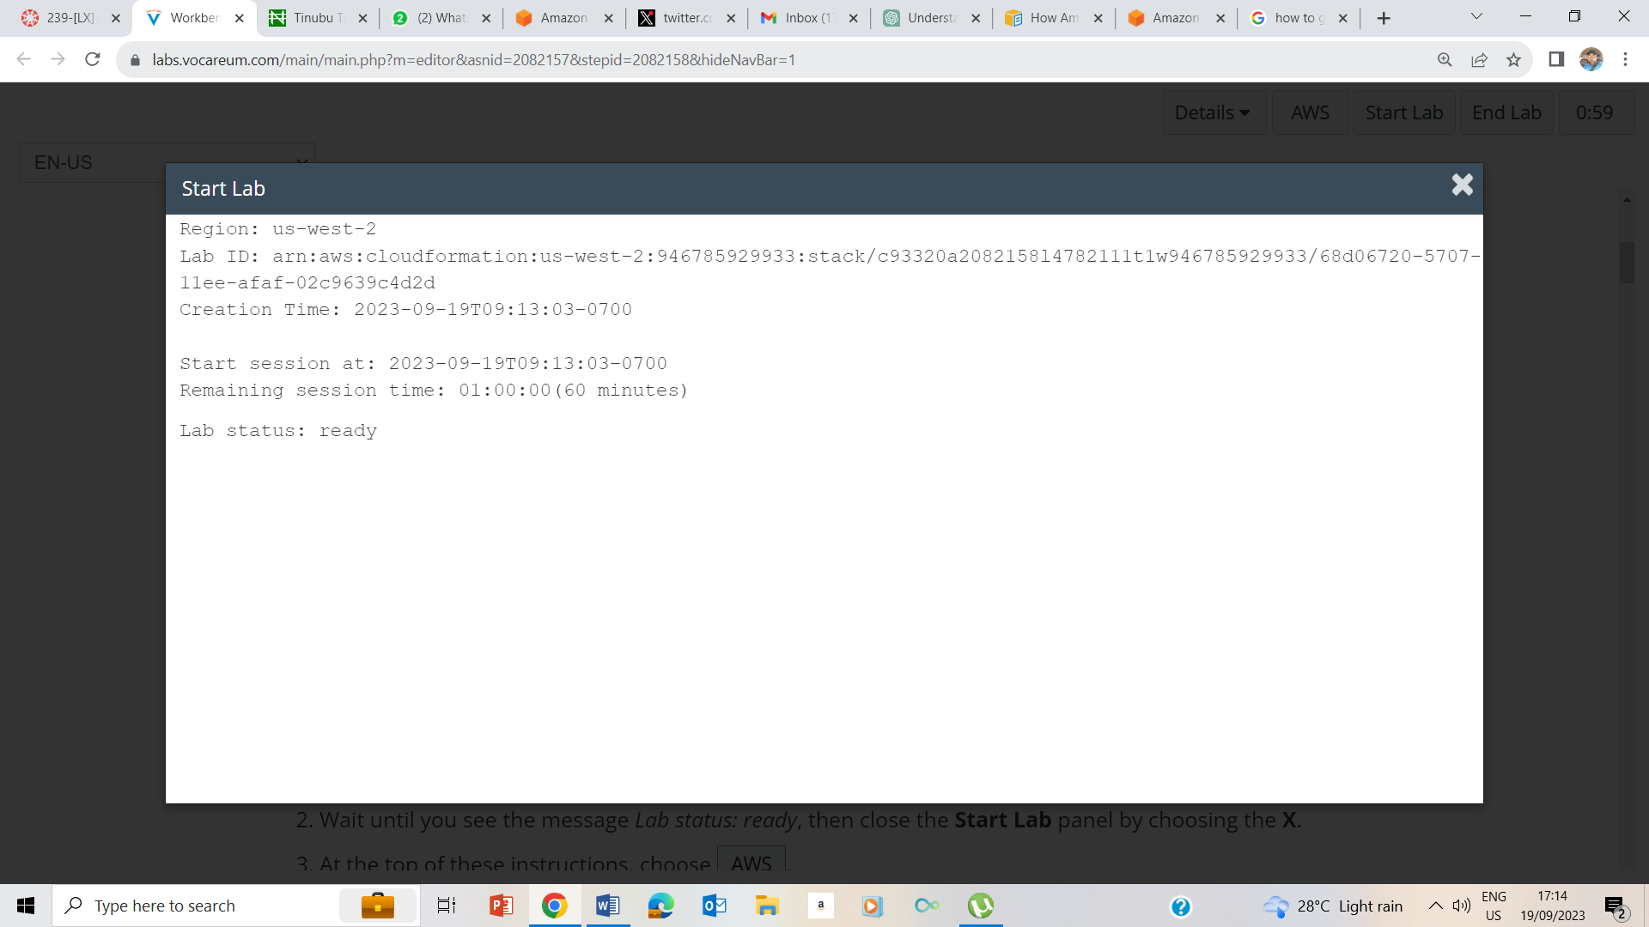

1-2 Starting of the lab

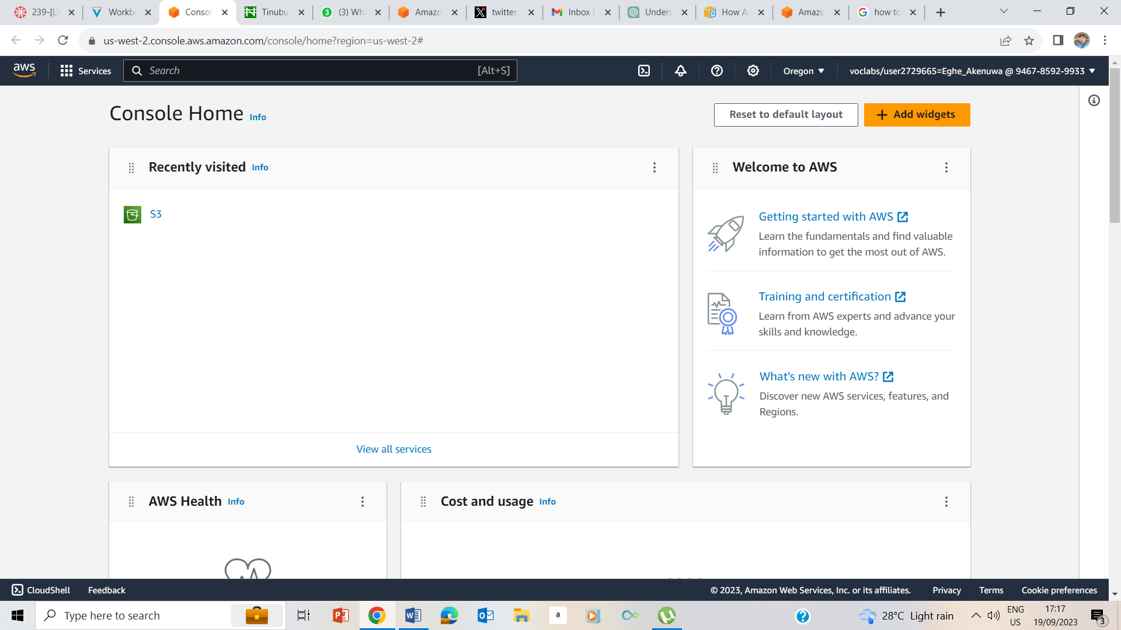

3. Choose AWS at the top of the instruction page.

## Task 1: Use SSH to connect to an Amazon Linux EC2 instance

### Windows Users: Using SSH to Connect

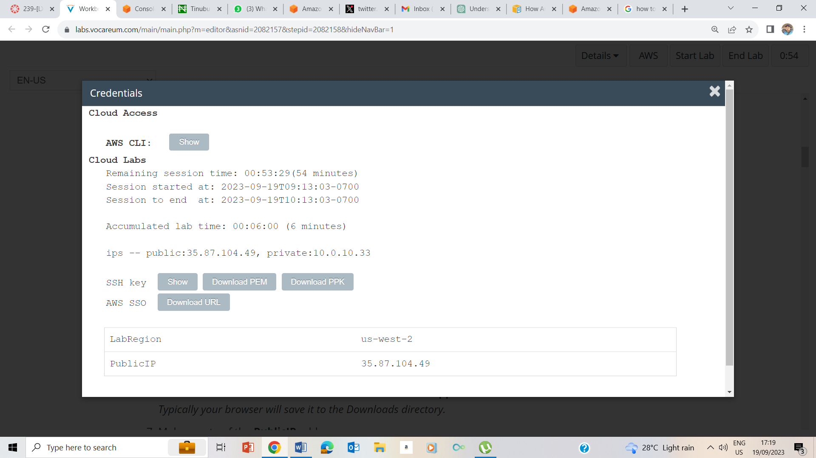

5-8 On the Details dropdown box, I clicked on show, downloaded the ppk file, and noted the public ip address as 35.87.104.49 and exited.

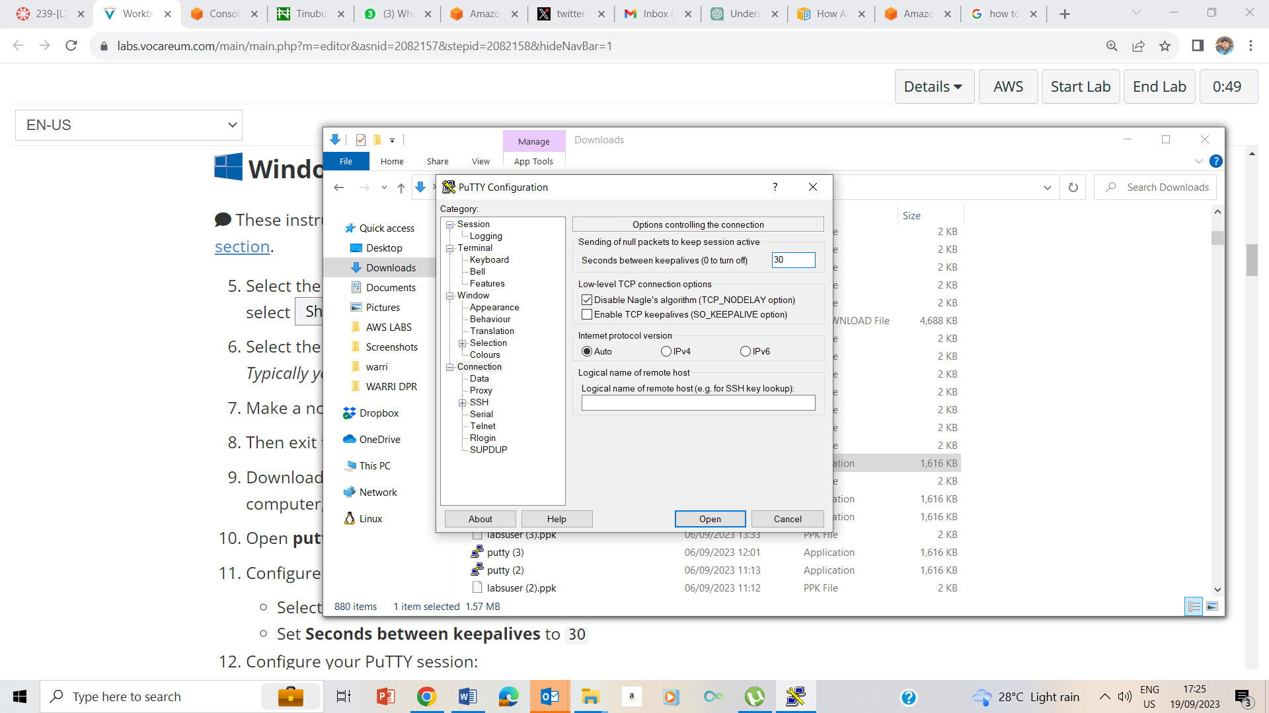

9-11 Downloaded putty, ran the putty.exe file, set connection seconds between keepalive to 30.

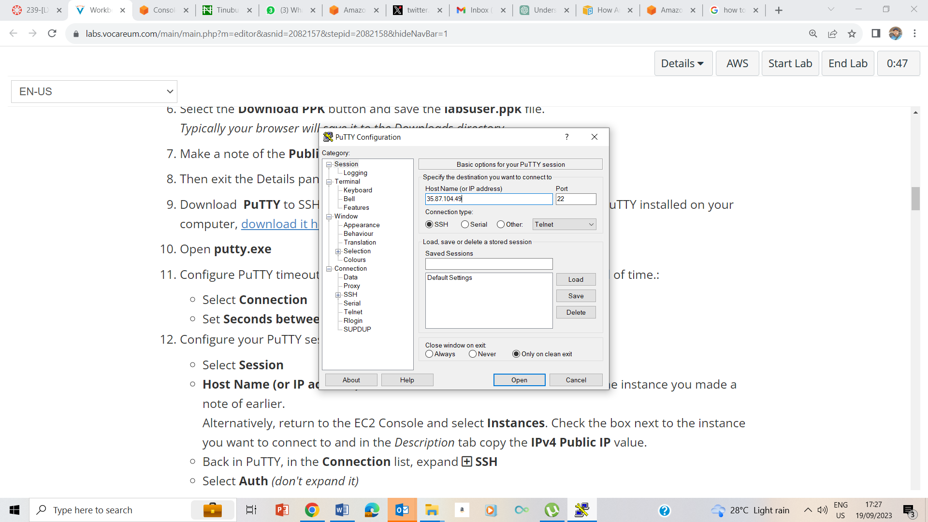

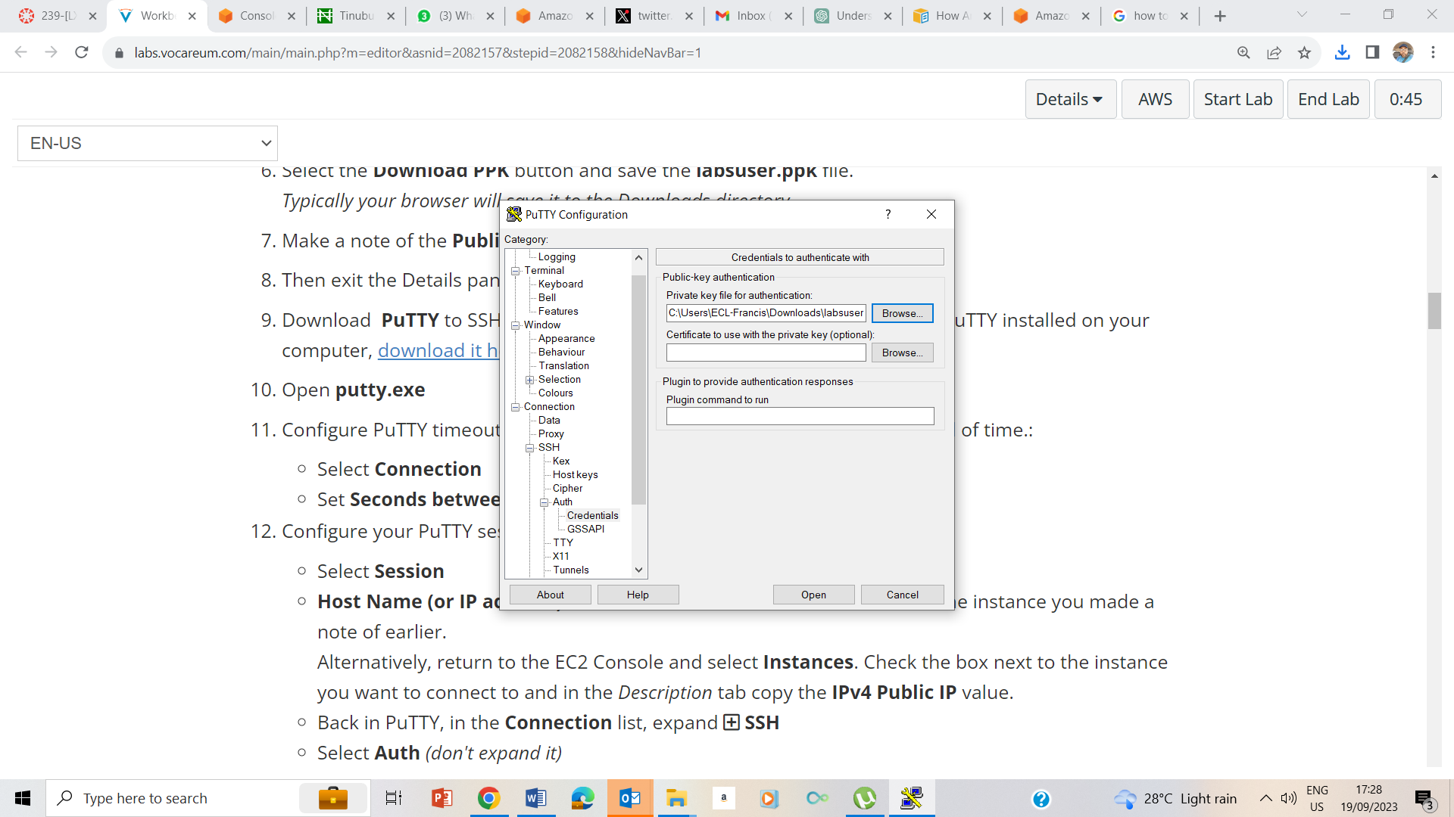

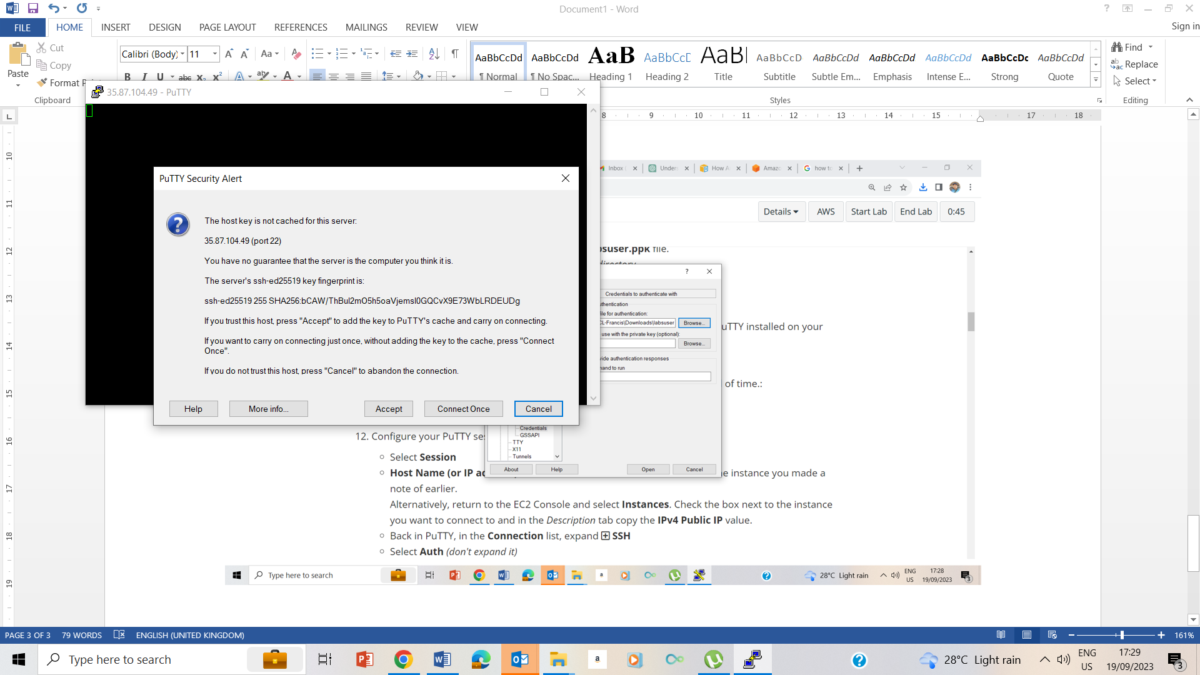

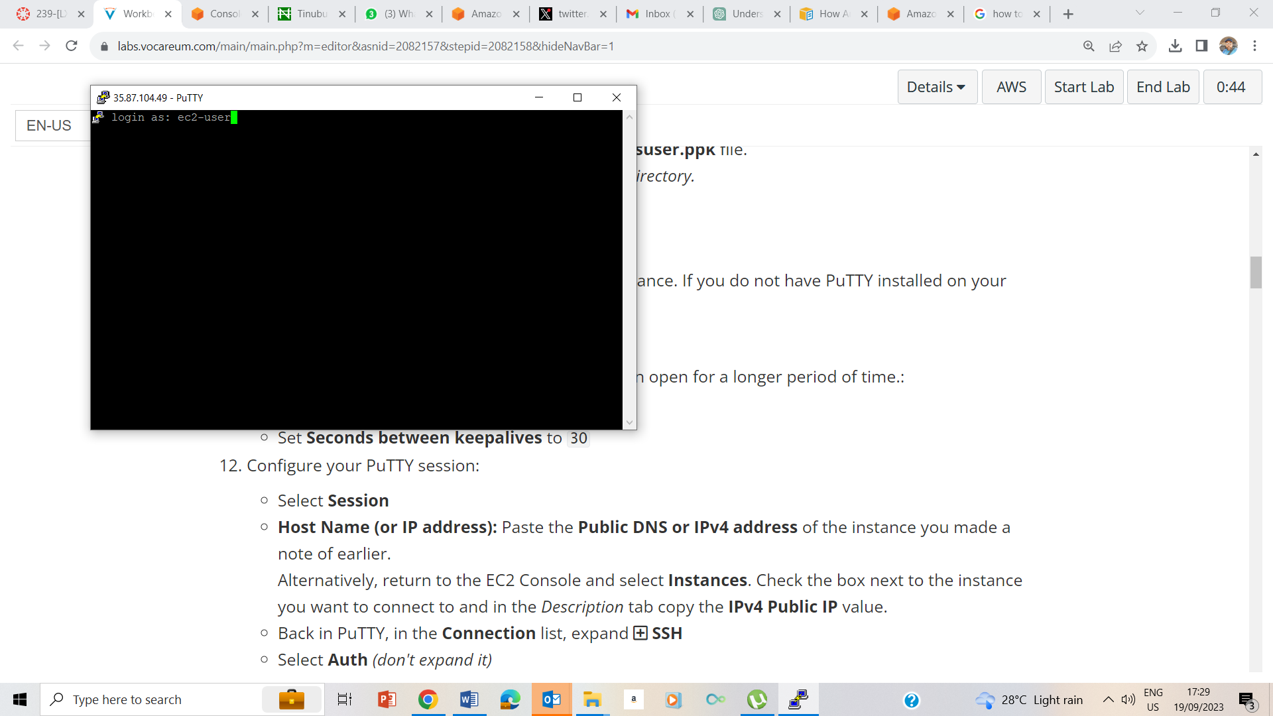

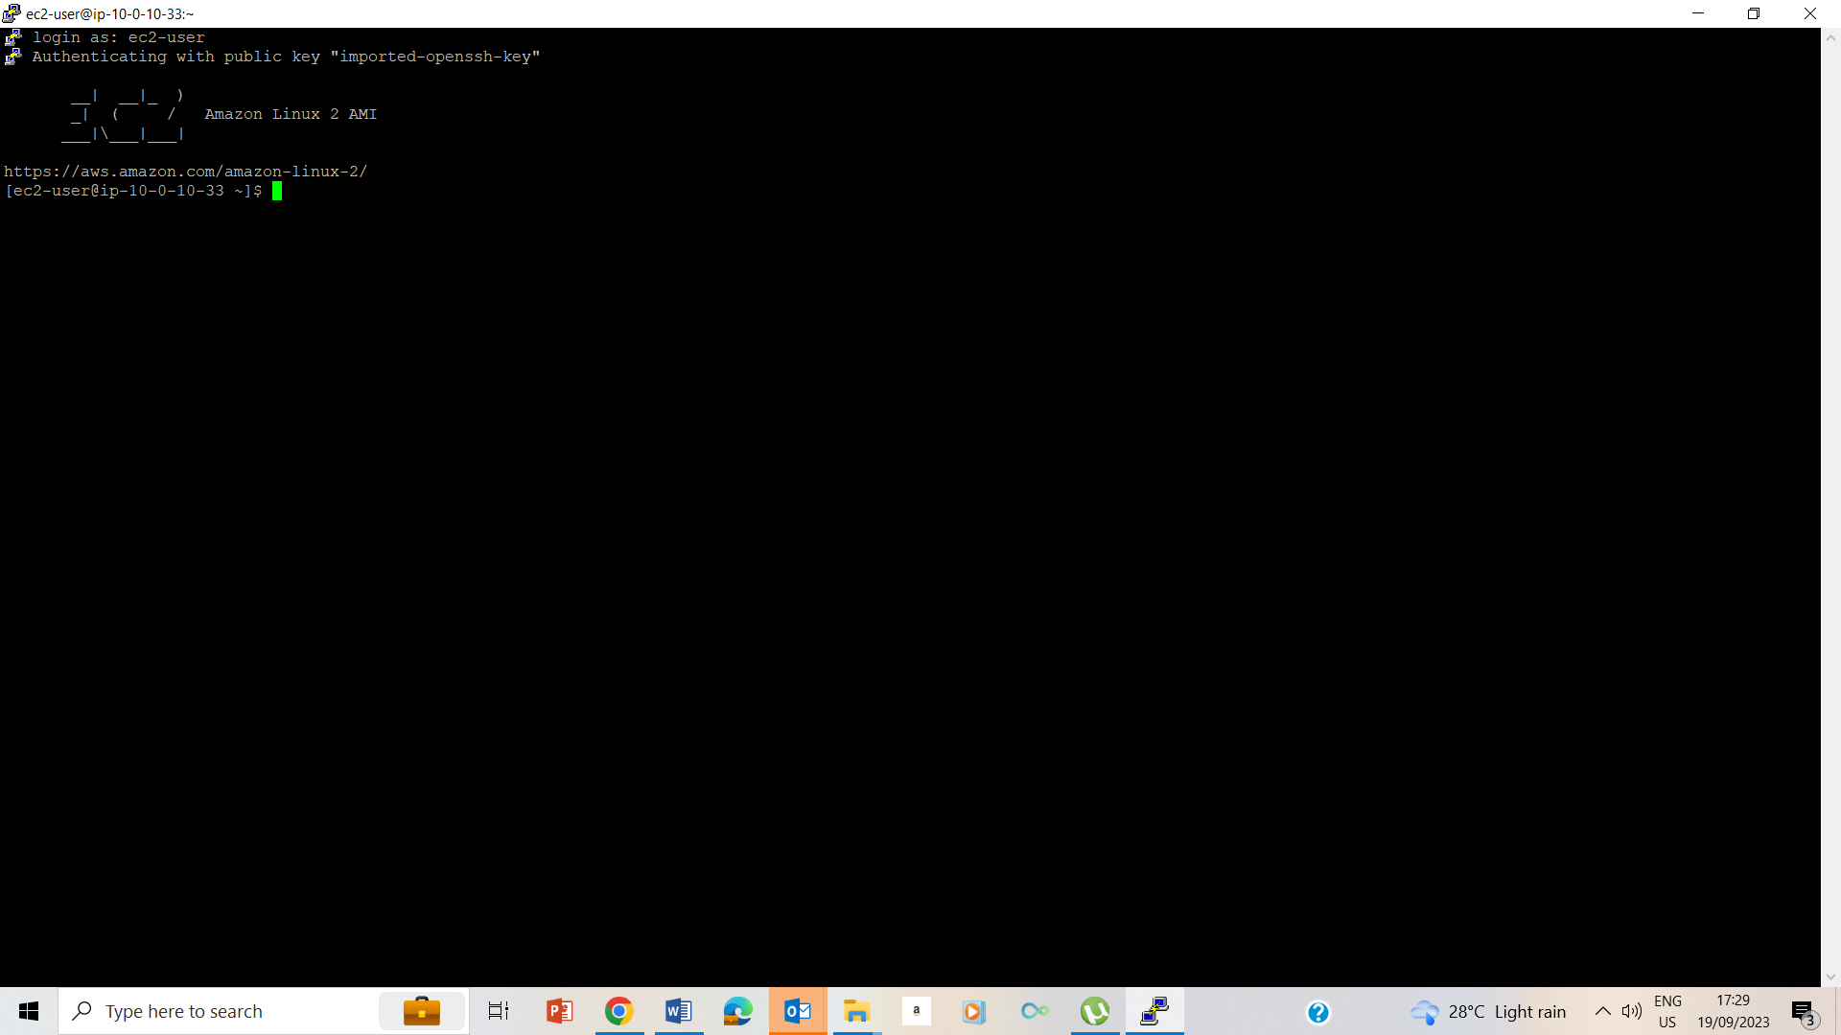

12-15 Configuring the putty

## Task 2: Exercise - Create List of Processes

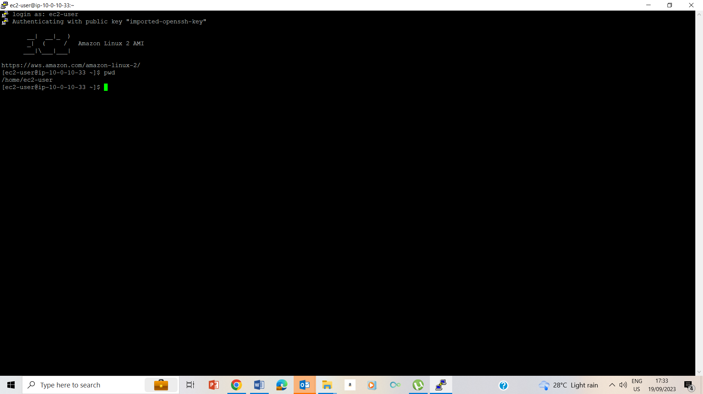

24. validating that I am on the /home/ec2-user/companyA folder by typing pwd and enter

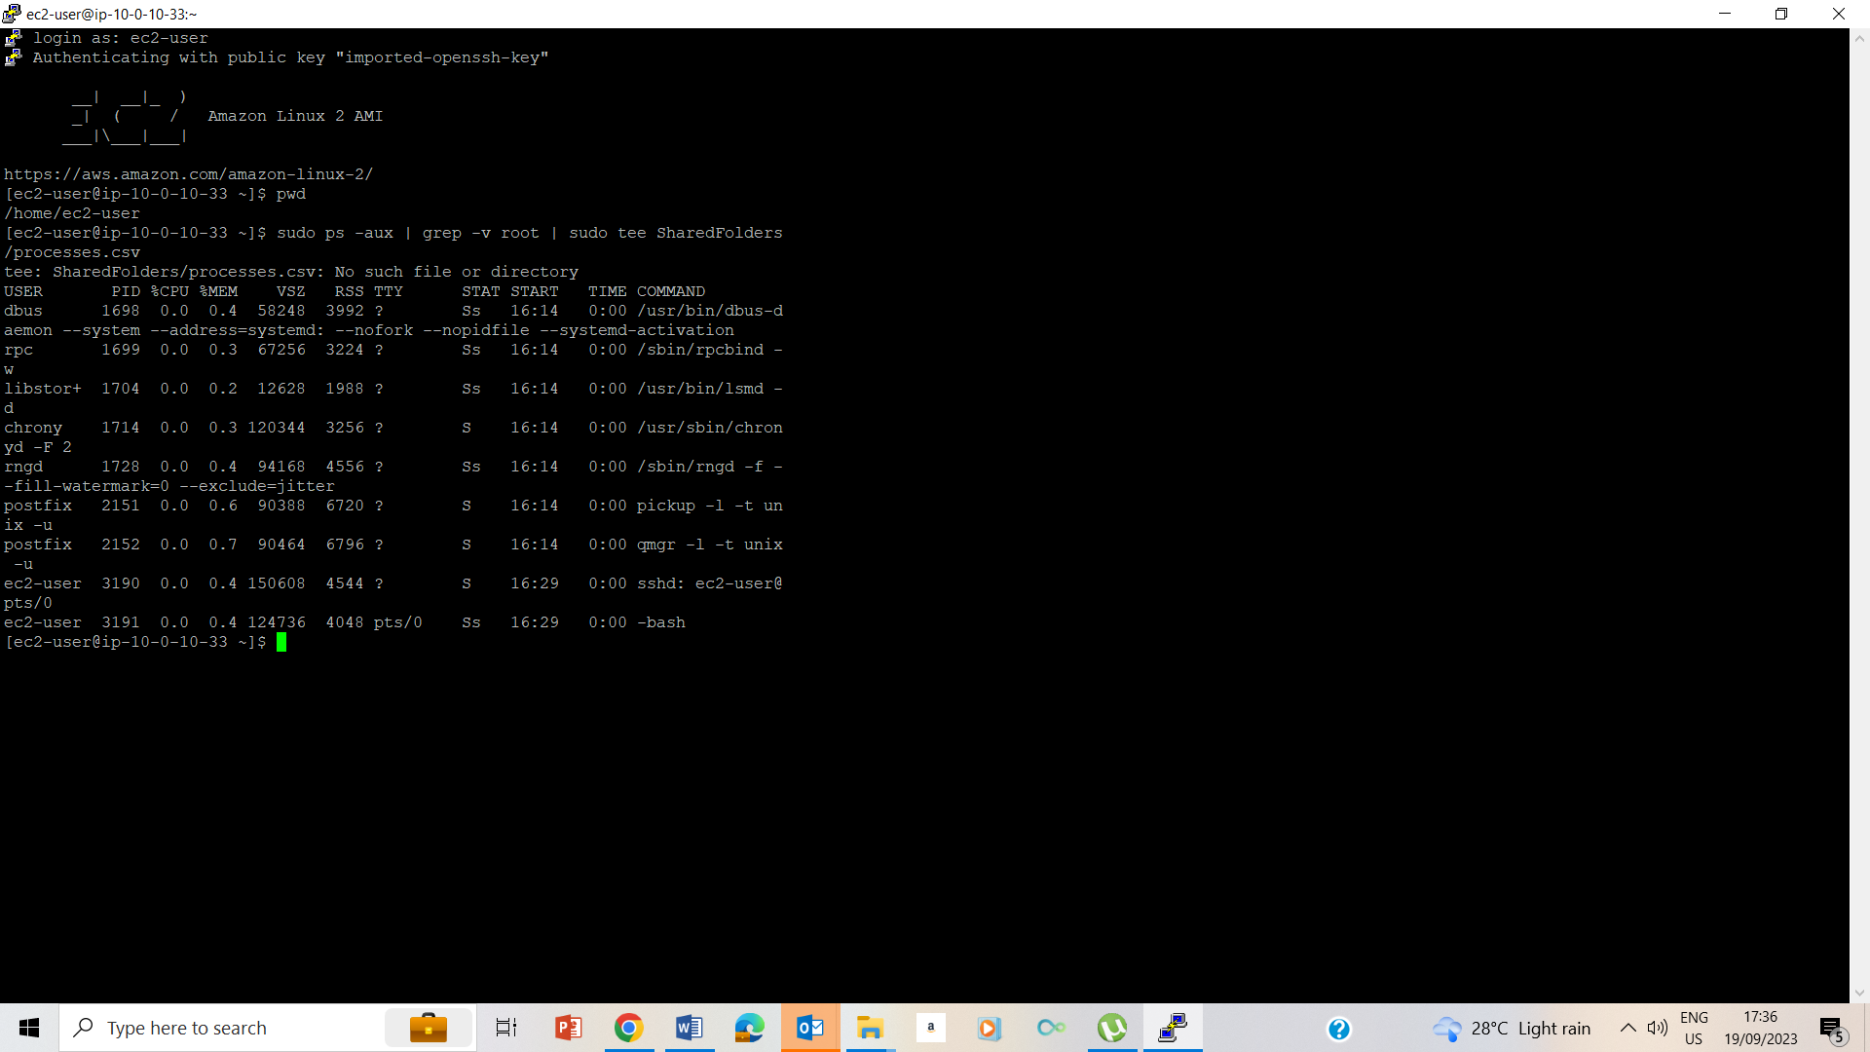

25. View all processes running on the machine and filter out the word root by typing sudo ps -aux | grep -v root | sudo tee SharedFolders/processes.csv and pressing ENTER

## Task 3: Exercise - List the processes using the top command

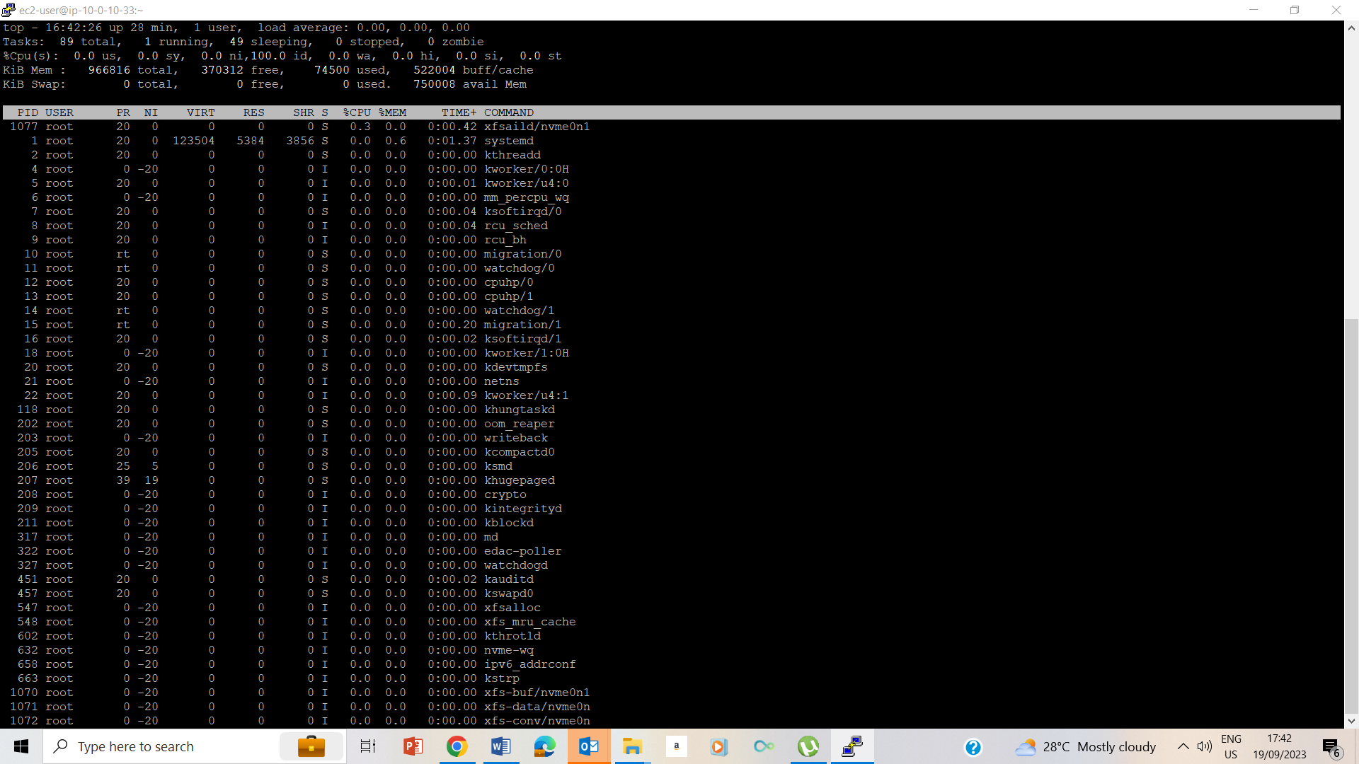

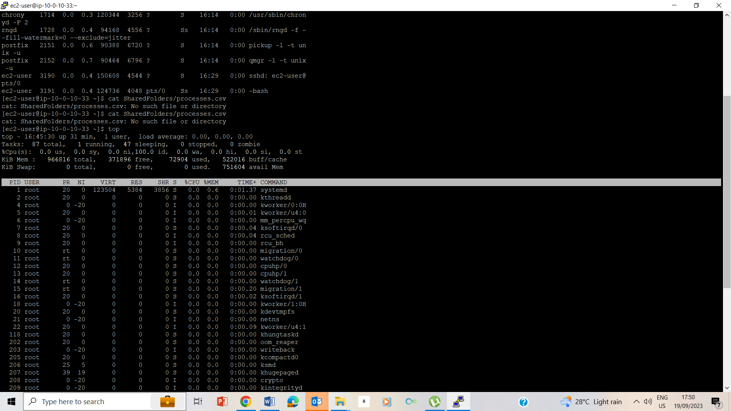

27-28. Running of the top command and we note that we have 1 task running.

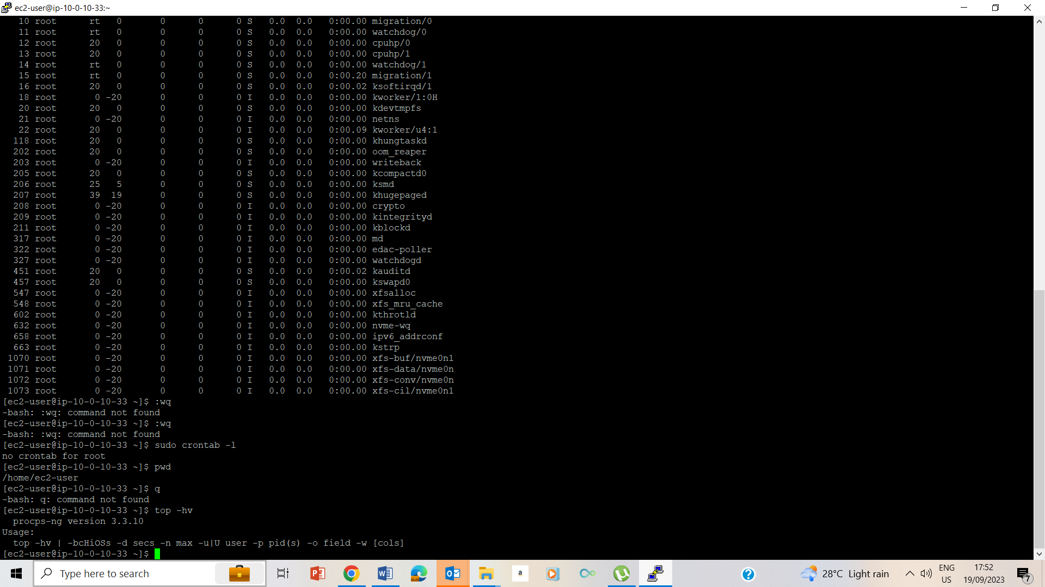

30. I used top –hv to find usage and version option

## Task 4: Exercise - Create a Cron Job



31-33. Validated that I was on the /home/ec2 folder with pwd; created a cron job that edits file with sudo crontab –e and used I to inter insert mode.

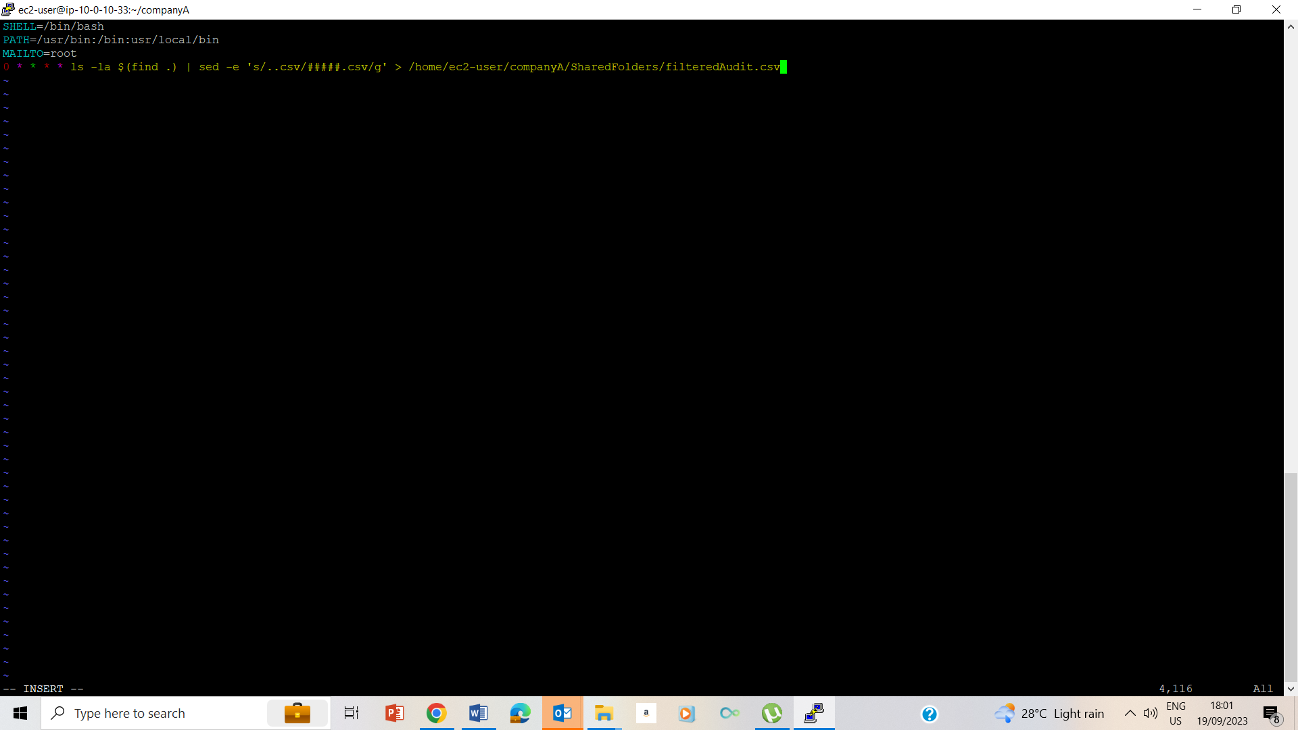

34-37. Followed the instruction on writing on the insert mode.

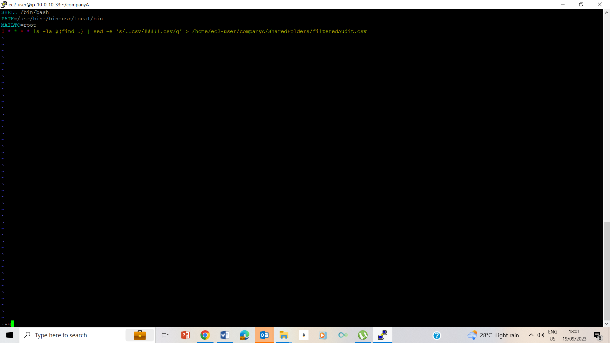

38. typed esc and :wq to save and exit

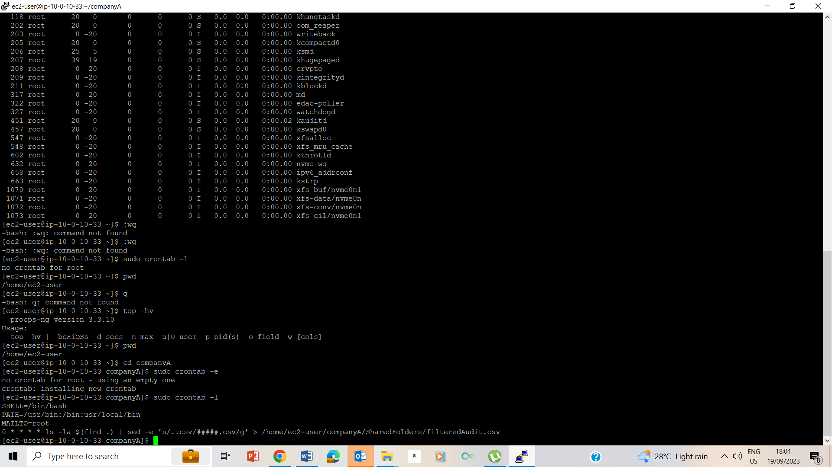

39. I used sudo crontab –l to validate my work.

## Lab Complete

